Spring Core Maven
Name: NALLANI LOKAKALYAN
Registered Mail: 2300030853cseh1@gmail.com
Exercise 1: Configuring a Basic Spring Application
LibraryManagementPom.xml:
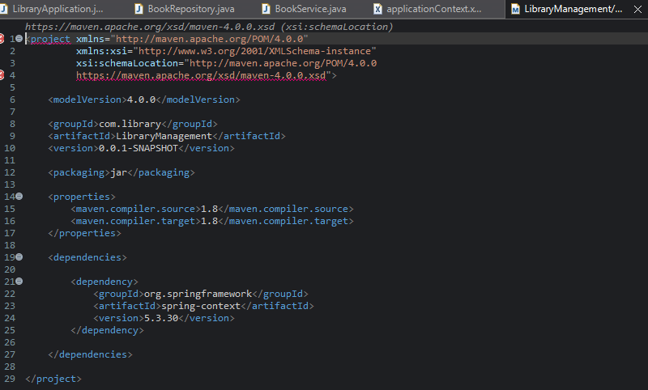
BookRepository.java:
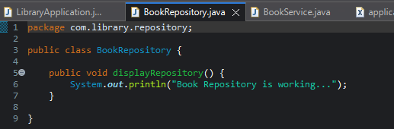
BookService.java:
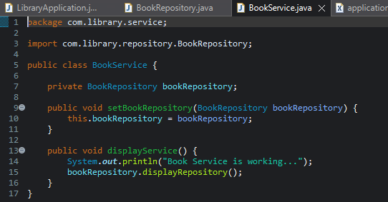
ApplicationContext.xml:
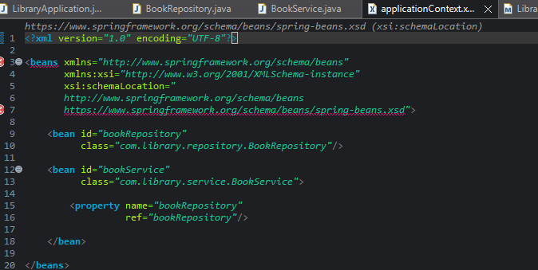
LibraryApplication.java:
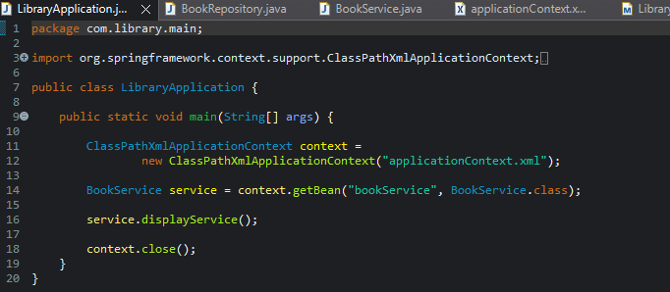
Output:
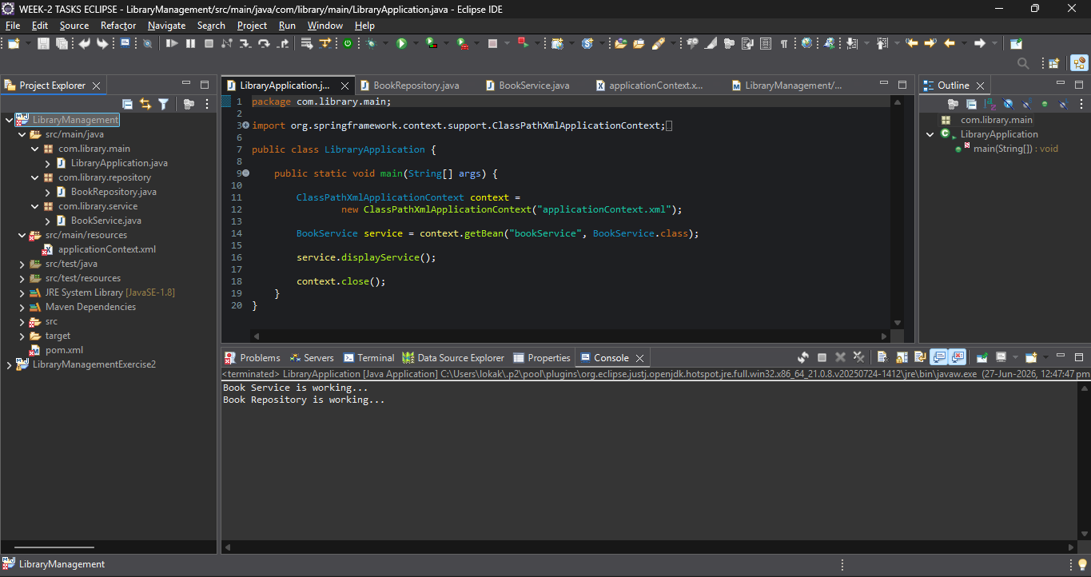

Exercise 2: Implementing Dependency Injection:
LibraryManagementExercise2Pom.xml:
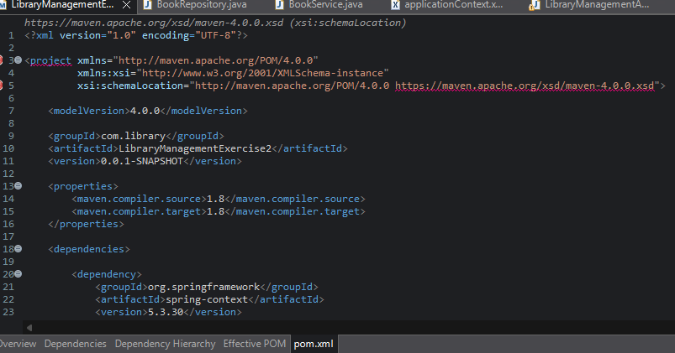
BookRepository.java:
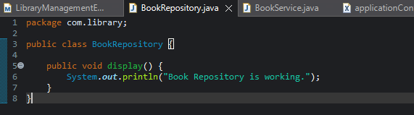
BookService.java:
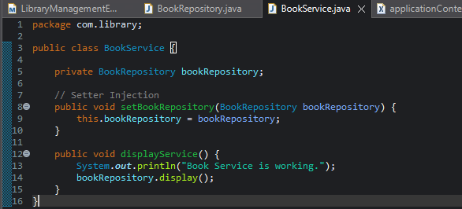
ApplicationContext.xml:
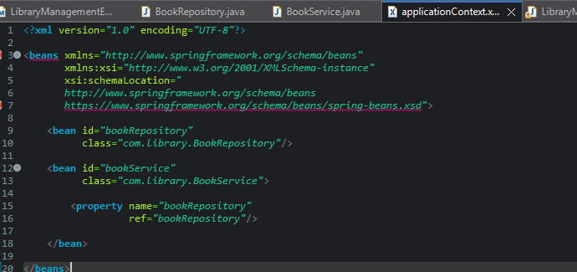
LibraryManagementApplication.java:
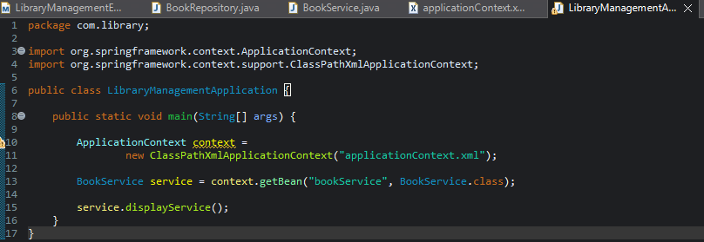
Output:
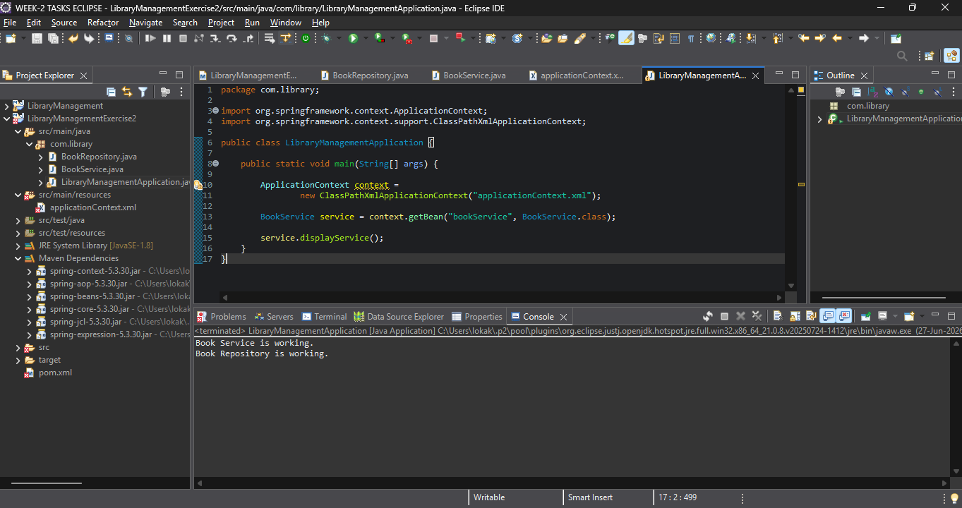
Exercise 4: Creating and Configuring a Maven Project:
Maven Dependencies:
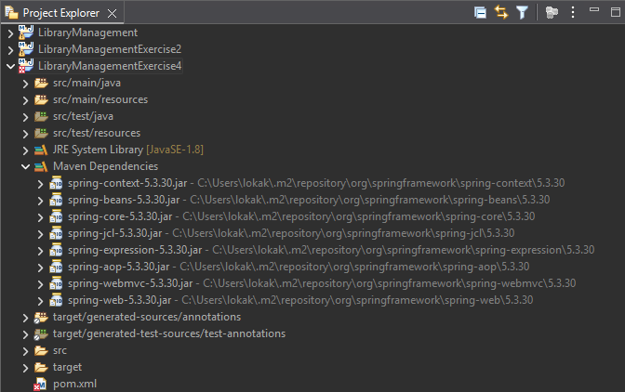
LibraryManagementExercise4Pom.xml:
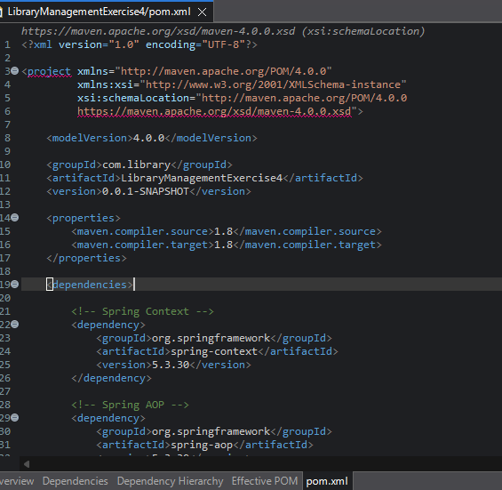
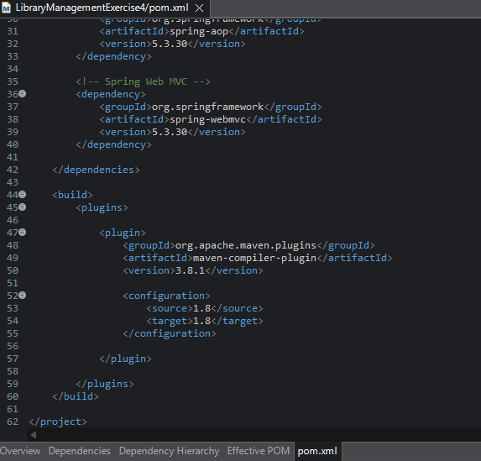

Output:
